**S3 Bucket Creation**

***Here you will learn how to create a new Bucket using AWS S3***

*Follow the given steps :*

1. **Sign in to AWS account and go to AWS management console.**

**Under Storage & Content Delivery, choose S3 to open the Amazon S3 console.**

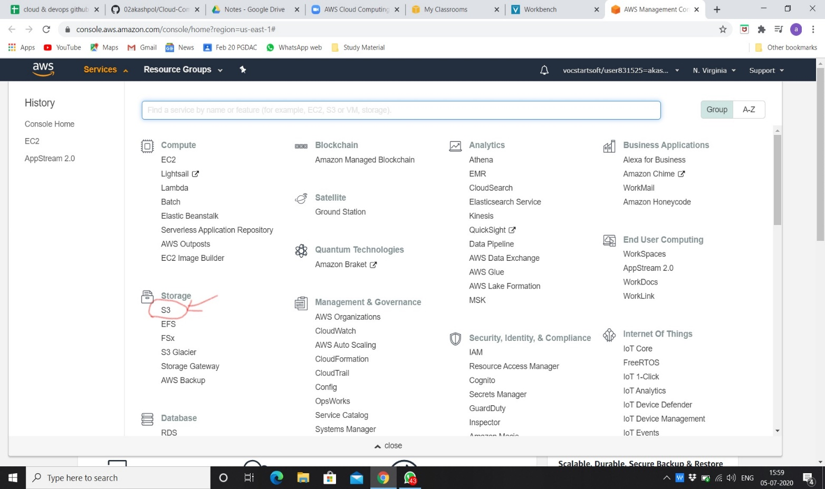

1. **Click on create bucket.**

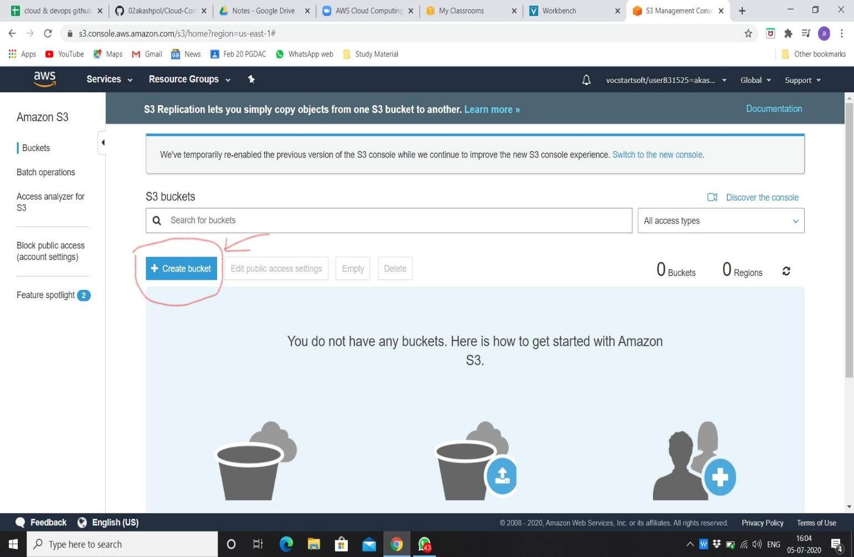

1. **Give unique name to bucket that name will not same as existing buckets in that specific region.**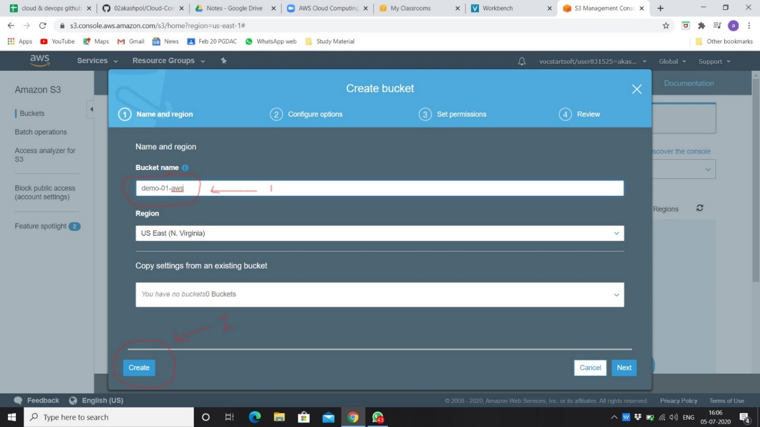
2. **For creating any folder in our bucket.**

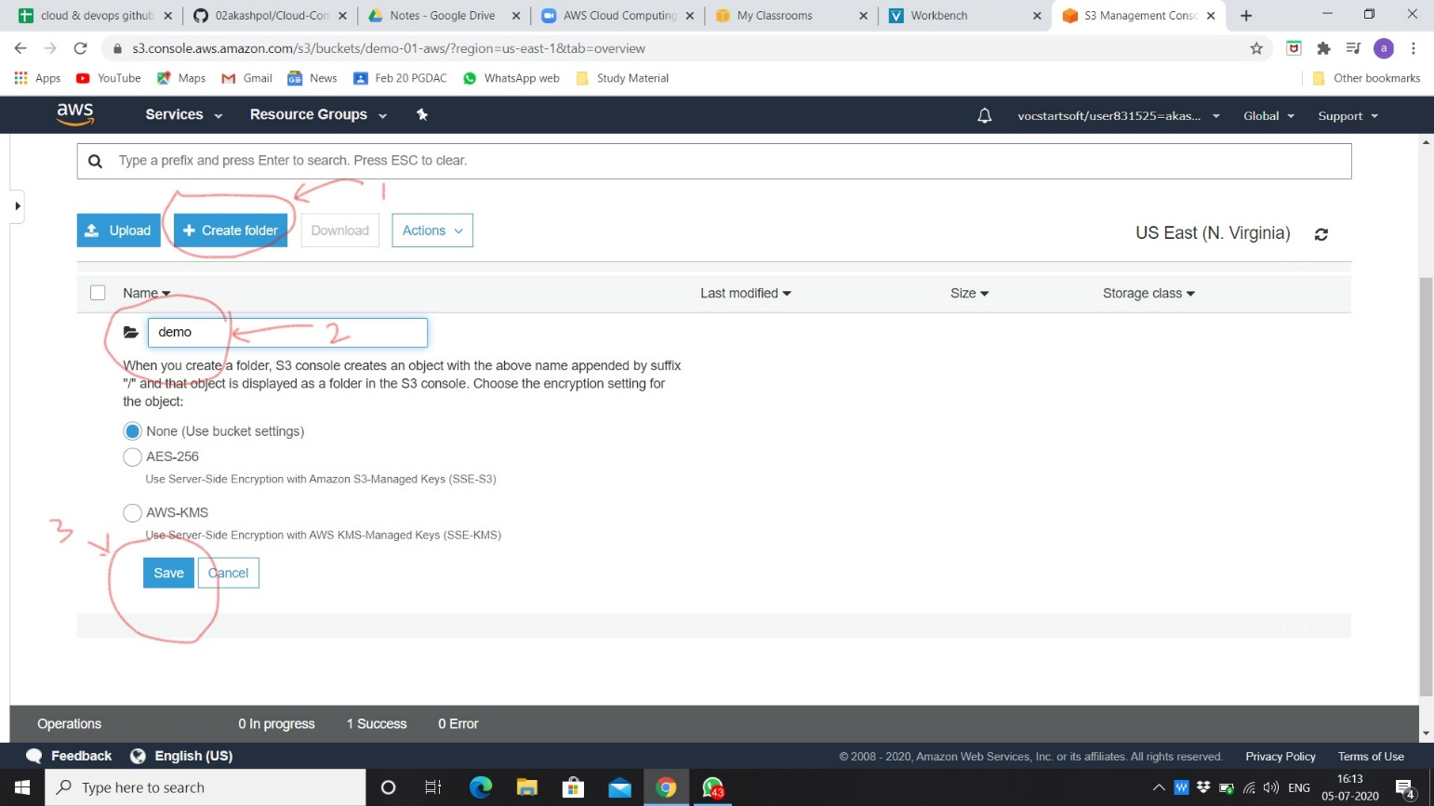

1. **Created folder in that bucket.**

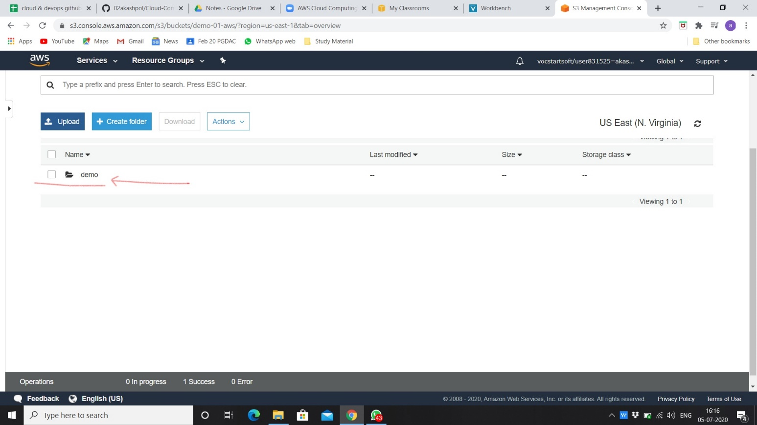

1. **For uploading any file in bucket.**

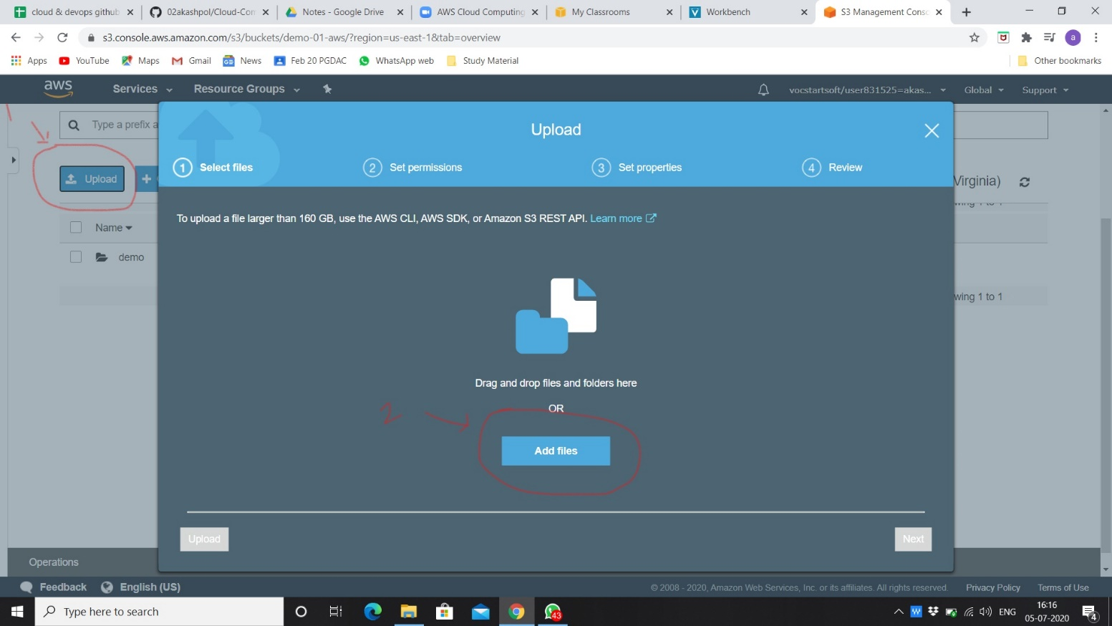

1. **Choose file for uploading.**

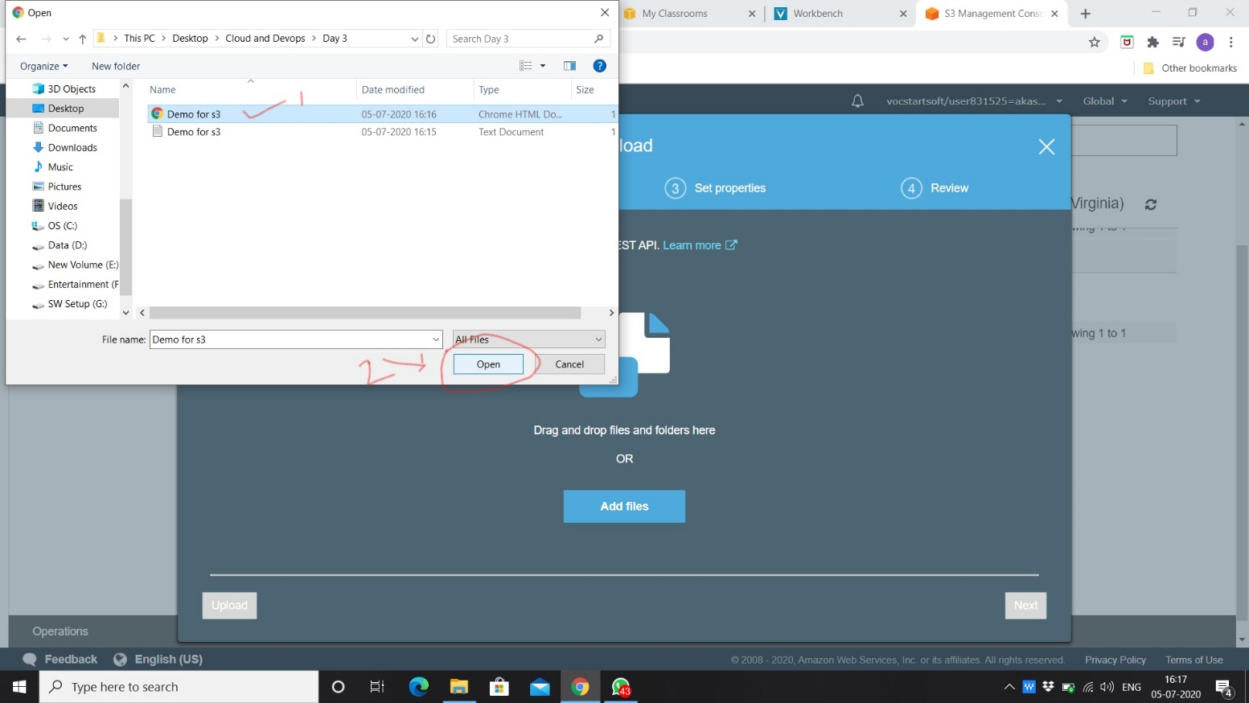

1. **Click on upload.**

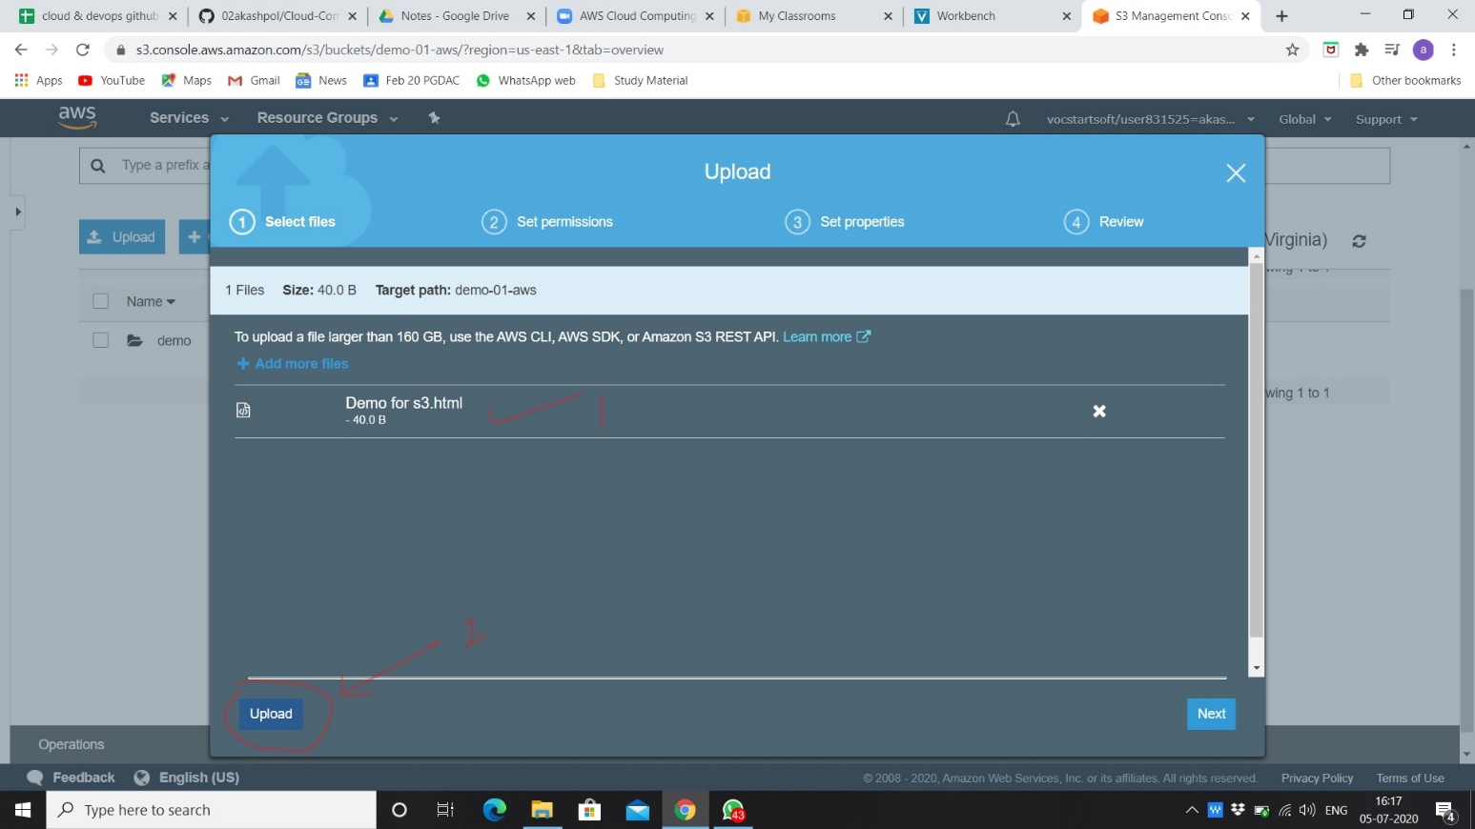

1. **Uploading file as shown in fig started uploading of file.**

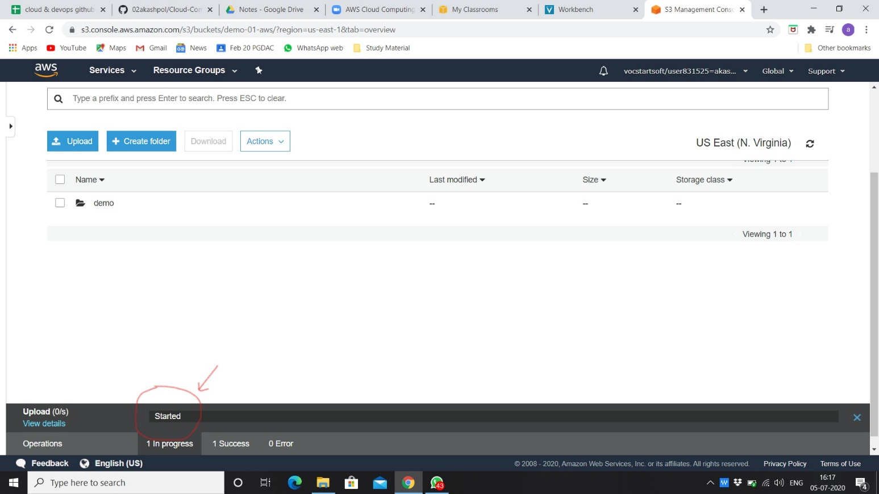

1. **File uploaded successfully.**

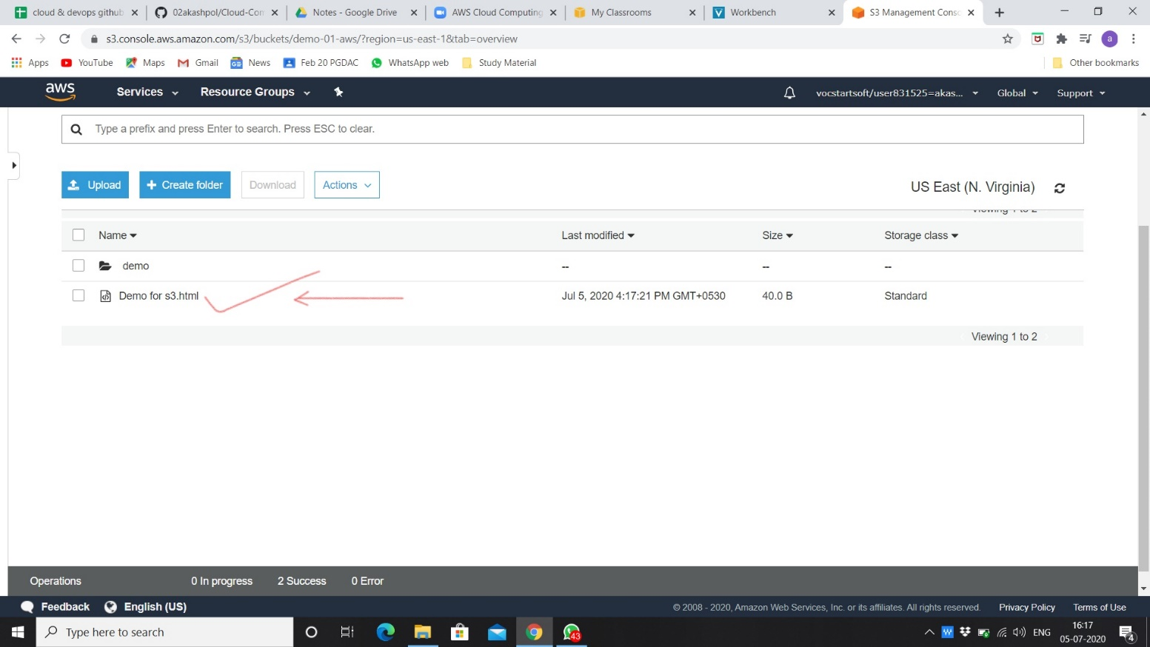

1. **For opening the file which was uploaded.**

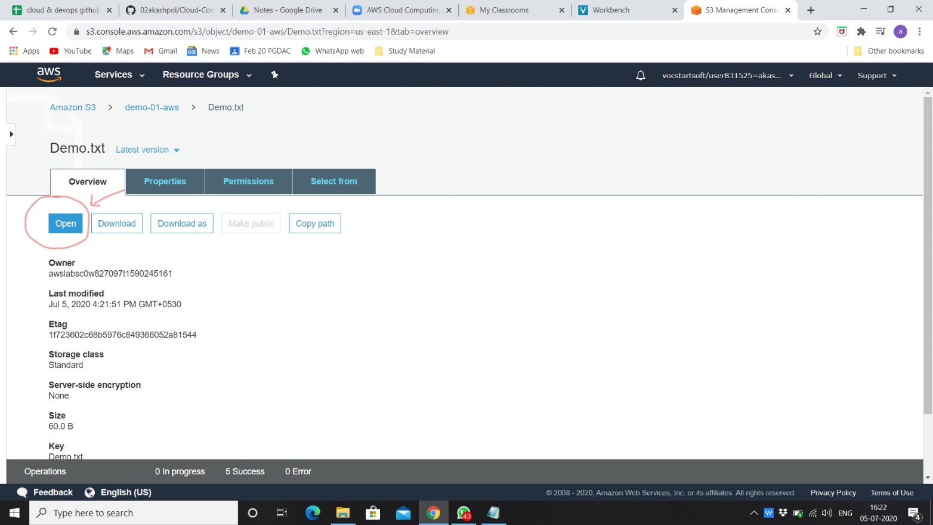

1. **Content of file.**

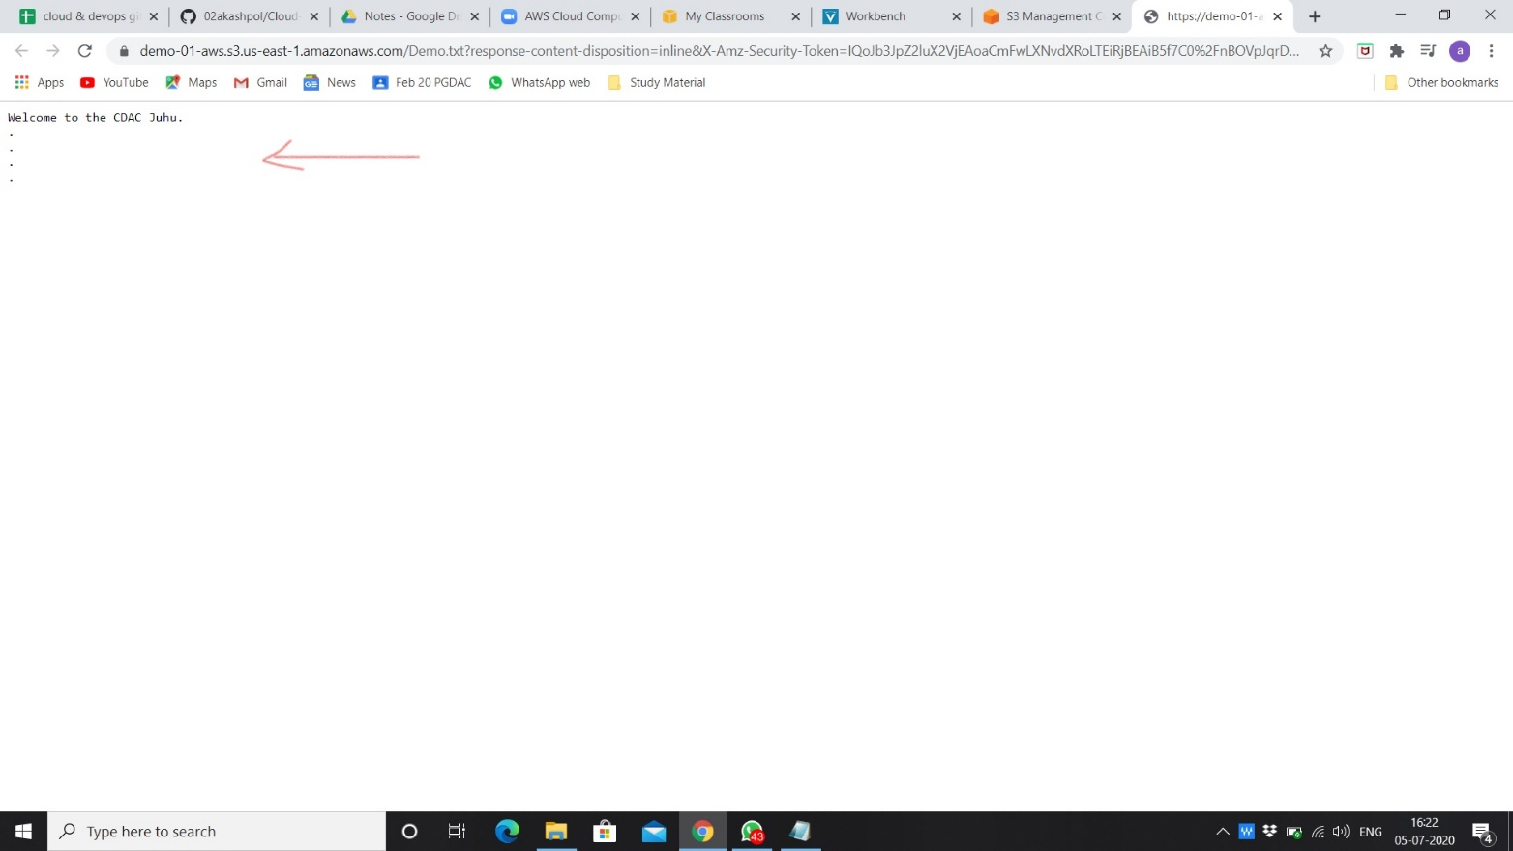

1. **Changing content in original file and uploading in previous folder that same file.**

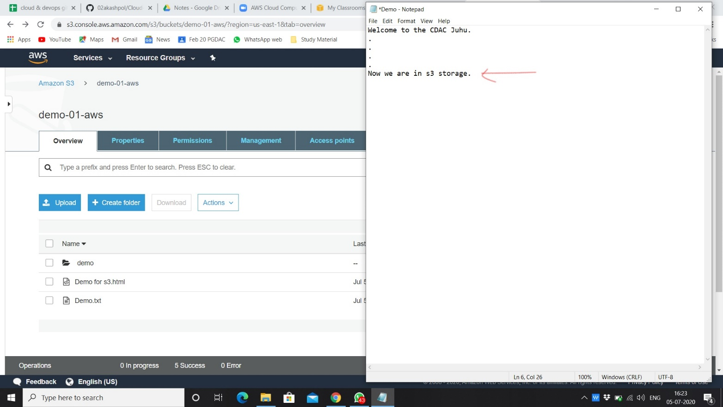

1. **Choosing the same file.**

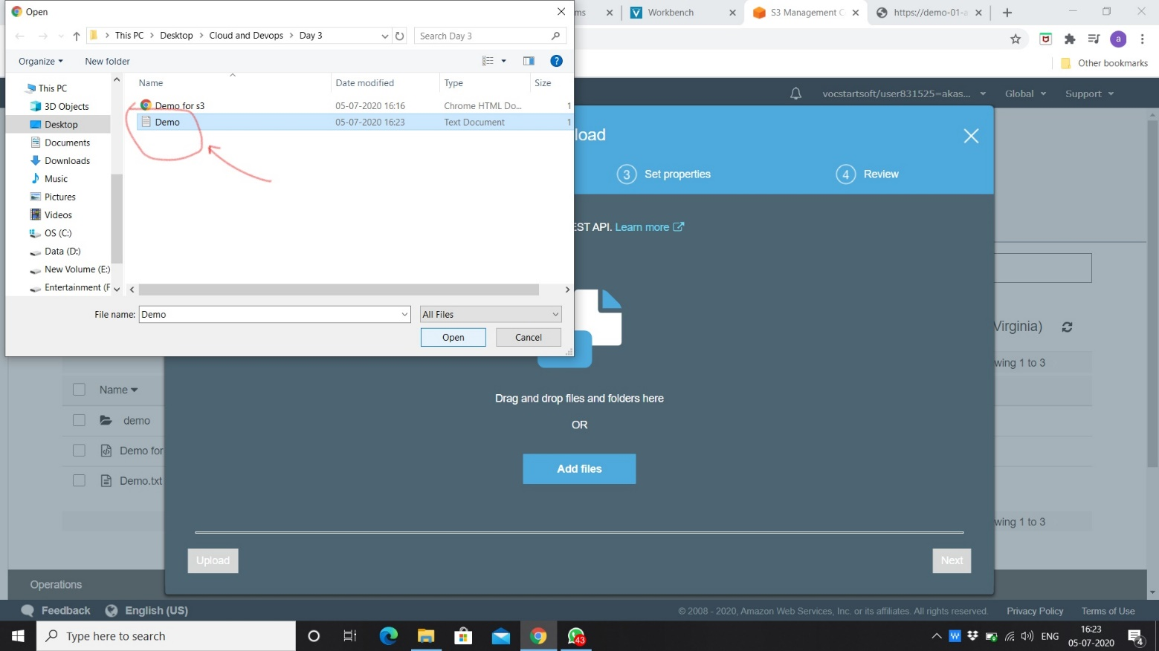

1. **Replaced old file with new file with new content.**

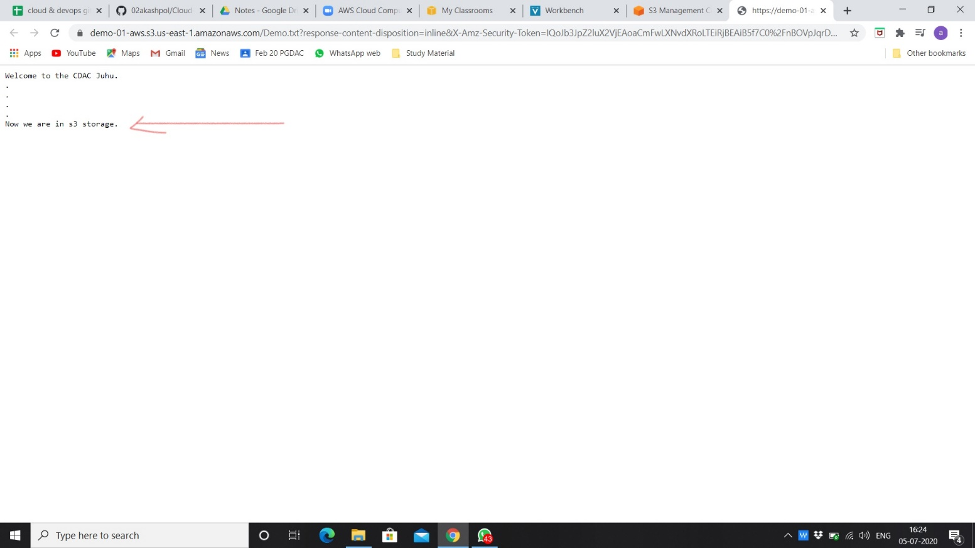

1. **New uploaded file.**

